19 Editors - Properties Editor - Render Tab
Detailed Table of content 4
Render Tab 11
Cycles Feature Set 11
Cycles Device 12
Color Management panel - All Renderers 12
Display Device 12
View Transform 12
Look 13
Exposure 13
Gamma 13
Sequencer Color Space 13
Use Curves 13
Cycles and Eevee - Freestyle panel 14
What is FreeStyle? 14
Enable 15
Line Thickness Mode 15
Line Thickness 15
Cycles - Sampling panel 15
Presets 15
Integrator 16
Render 16
Viewport 16
Sub Samples (Branched Path Tracing) 16
Advanced 17
Cycles - Light Paths panel 18
Presets 18
Max Bounces 18
Clamping 19
Caustics 19
Cycles - Volumes panel 19
Step Size 20
Max Steps 20
Cycles - Subdivision panel 20
Dicing Rate Render 20
Preview 20
Offsceen Scale 20
Max Subdivisions 20
Dicing Camera 20
Cycles - Hair panel 20
Min Pixels 20
Max Extension 21
Shape 21
Primitive 21
Cycles - Simplify panel 21
Enable 21
Viewport 22
Render 22
Culling 22
Cycles - Motion Blur panel 23
Enable 23
Position 23
Shutter 23
Rolling Shutter 23
Rolling Sutter Duration 23
Shutter Curve 23
Cycles - Film panel 25
Exposure 25
Pixel Filter 25
Transparent 25
Cycles - Performance panel 25
Threads 26
Tiles 26
Acceleration Structure 26
Final Render 27
Viewport 27
Cycles - Bake panel 27
Settings for all Texture types 28
OpenGL - Lighting panel 30
Flat 31
Studio 31
Matcap 31
OpenGL - Color panel 31
Single 32
Material 32
Random 32
Texture 32
OpenGL - Options panel 32
X Ray 32
Shadow 32
Cavity 32
Outline 32
Specular Highlights 32
OpenGL - Film panel 33
Anti Aliasing 33
Anti Aliasing Sample 33
Alpha Mode 33
OpenGL - Simplify panel 33
Enable 33
Viewport 33
Render 34
Eevee - Sampling panel 34
Viewport Samples 34
Render Samples 34
Viewport Denoising 34
Eevee - Ambient Occlusion panel 34
Enable 34
Distance 34
Factor 34
Trace Precision 35
Bent Normals 35
Bounces Approximation 35
Eevee - Bloom panel 35
Enable 35
Threshold 35
Knee 35
Radius 35
Color 35
Intensity 35
Clamp 35
Eevee - Depth of Field panel 35
Enable 36
Max Size 36
Sprite Threshold 36
Eevee - Subsurface Scattering panel 36
Enable 36
Samples 36
Jitter Threshold 36
Separate Albedo 36
Eevee - Screen Space reflections panel 36
Enable 36
Refraction 36
Half Res Trace 37
Trace Precision 37
Max Roughness 37
Thickness 37
Edge Fading 37
Clamp 37
Eevee - Motion Blur panel 37
Enable 37
Samples 37
Shutter 37
Eevee - Volumetric panel 37
Enable 38
Start 38
End 38
Tile Size 38
Samples 38
Exponential sampling 38
Volumetric Lighting 38
Volumetric Shadows 38
Eevee - Hair panel 39
Hair Shape Type 39
Additional Subdiv 39
Eevee - Shadows panel 39
Method 39
Cube Size 39
Cascade Size 39
High Bitdepth 39
Soft Shadows 39
Eevee - Indirect Lighting panel 40
Bake Indirect Lighting 40
Bake Cubemap Only 40
Free Lighting Cache 40
Auto Bake 40
Diffuse Bounces 40
Cubemap Size 40
Diffuse Occlusion 40
Display 40
Eevee - Film panel 41
Overscan 41
Filter Size 41
Alpha Mode 41
Eevee - Simplify panel 42
Enable 42
Viewport 42
Render 42
Grease Pencil 43

Detailed Table of content

3.8.2 - Editors - Properties Editor - Render Tab
Detailed Table of content 4
Render Tab 11
Cycles Feature Set 11
Cycles Device 12
Open Shading Language 12
Color Management panel - All Renderers 12
Display Device 12
View Transform 12
Default 12
Filmic 12
RRT 12
Film 12
Raw 13
Log 13
False Color 13
Look 13
Exposure 13
Gamma 13
Sequencer Color Space 13
Use Curves 13
Navigation elements 13
Zoom in and out 13
Tools 14
Reset View 14
Vector Handle 14
Auto Handle 14
Auto Clamped Handle 14
Reset Curve 14
Use Clipping 14
Delete Points 14
Black Level 14
White Level 14
Reset 14
Cycles and Eevee - Freestyle panel 14
What is FreeStyle? 14
Enable 15
Line Thickness Mode 15
Absolute 15
Relative 15
Line Thickness 15
Cycles - Sampling panel 15
Presets 15
Integrator 16
Render 16
Viewport 16
Sub Samples (Branched Path Tracing) 16
Diffuse Samples 16
Glossy Samples 16
Transmission Samples 16
AO Samples 16
Mesh Light Samples 16
Subsurface Samples 16
Volume Samples 16
Total Samples 16
Advanced 17
Seed 17
Animate Seed 17
Pattern 17
Sobol 17
Correlated Multi-Jitter 17
Square Samples 17
Light Threshold 17
Sample all direct lights (Branched Path Tracing) 17
Sample all indirect lights (Branched Path Tracing) 17
Cycles - Light Paths panel 18
Presets 18
Max Bounces 18
Total 18
Diffuse 18
Glossy 18
Transparency 18
Transmission Bounces 18
Volume Bounces 18
Clamping 19
Direct Light 19
Indirect Light 19
Caustics 19
Filter Glossy 19
Reflective Caustics 19
Refractive Caustics 19
Cycles - Volumes panel 19
Step Size 20
Max Steps 20
Cycles - Subdivision panel 20
Dicing Rate Render 20
Preview 20
Offsceen Scale 20
Max Subdivisions 20
Dicing Camera 20
Cycles - Hair panel 20
Min Pixels 20
Max Extension 21
Shape 21
Cull Backfaces (Thick) 21
Primitive 21
Triangles 21
Resolution 21
Line Segments 21
Curve Segments 21
Curve Subdivision 21
Cycles - Simplify panel 21
Enable 21
Viewport 22
Max Subdivisions 22
Child Particles 22
Texture Limit 22
AO Bounces 22
Render 22
Max Subdivisions 22
Child Particles 22
Texture Limit 22
AO Bounces 22
Culling 22
Use Camera Cull 22
Camera cull margin 23
Use Distance Cull 23
Distance 23
Cycles - Motion Blur panel 23
Enable 23
Position 23
Shutter 23
Rolling Shutter 23
Rolling Sutter Duration 23
Shutter Curve 23
Navigation elements 24
Zoom in and out 24
Tools 24
Reset View 24
Vector Handle 24
Auto Handle 24
Auto Clamped Handle 24
Reset Curve 24
Use Clipping 24
Delete Points 24
Black Level 24
White Level 24
Reset 24
Presets 24
Cycles - Film panel 25
Exposure 25
Pixel Filter 25
Type 25
Width 25
Transparent 25
Transparent Glass 25
Roughness Threshold 25
Cycles - Performance panel 25
Threads 26
Mode 26
Auto-detect 26
Fixed 26
Threads 26
Tiles 26
Tile size X/Y 26
Order 26
Progressive Refine 26
Acceleration Structure 26
Use Spatial Splits 26
Use Hair BVH 26
BVH Time Steps 27
Final Render 27
Save Buffers 27
Persistent Images 27
Viewport 27
Pixel Size 27
Start Pixels 27
Cycles - Bake panel 27
Settings for all Texture types 28
Bake Type 28
Subsurface 28
Transmission 28
Glossy 28
Environment 28
Emit 28
Roughness 28
UV 28
Normals 28
Shadow 29
Ambient Occlusion 29
Combined 29
Margin 29
Clear Image 29
Selected to Active 29
Cage 29
Ray Distance 29
Bake 29
Settings for specific Texture types 29
Subsurface, Transmission, Glossy, Diffuse 29
Direct 29
Indirect 29
Color 30
Normal 30
Space 30
Swizzle 30
Combined 30
Direct 30
Indirect 30
Diffuse 30
Glossy 30
Transmission 30
Subsurface 30
AO 30
Emit 30
OpenGL - Lighting panel 30
Flat 31
Studio 31
Light library browser 31
Rotation 31
User Preferences 31
Matcap 31
User Preferences 31
Flip Matcap 31
OpenGL - Color panel 31
Single 32
Material 32
Random 32
Texture 32
OpenGL - Options panel 32
X Ray 32
Shadow 32
Shadow Shift 32
Cavity 32
Outline 32
Specular Highlights 32
OpenGL - Film panel 33
Anti Aliasing 33
Anti Aliasing Sample 33
Alpha Mode 33
Sky 33
Transparent 33
OpenGL - Simplify panel 33
Enable 33
Viewport 33
Max Subdivisions 33
Child Particles 33
Render 34
Max Subdivisions 34
Child Particles 34
Eevee - Sampling panel 34
Viewport Samples 34
Render Samples 34
Viewport Denoising 34
Eevee - Ambient Occlusion panel 34
Enable 34
Distance 34
Factor 34
Trace Precision 35
Bent Normals 35
Bounces Approximation 35
Eevee - Bloom panel 35
Enable 35
Threshold 35
Knee 35
Radius 35
Color 35
Intensity 35
Clamp 35
Eevee - Depth of Field panel 35
Enable 36
Max Size 36
Sprite Threshold 36
Eevee - Subsurface Scattering panel 36
Enable 36
Samples 36
Jitter Threshold 36
Separate Albedo 36
Eevee - Screen Space reflections panel 36
Enable 36
Refraction 36
Half Res Trace 37
Trace Precision 37
Max Roughness 37
Thickness 37
Edge Fading 37
Clamp 37
Eevee - Motion Blur panel 37
Enable 37
Samples 37
Shutter 37
Eevee - Volumetric panel 37
Enable 38
Start 38
End 38
Tile Size 38
Samples 38
Exponential sampling 38
Volumetric Lighting 38
Enable 38
Light Clamping 38
Volumetric Shadows 38
Enable 38
Shadow samples 38
Eevee - Hair panel 39
Hair Shape Type 39
Animate Propterty 39
Additional Subdiv 39
Animate Propterty 39
Eevee - Shadows panel 39
Method 39
Cube Size 39
Cascade Size 39
High Bitdepth 39
Soft Shadows 39
Eevee - Indirect Lighting panel 40
Bake Indirect Lighting 40
Bake Cubemap Only 40
Free Lighting Cache 40
Auto Bake 40
Diffuse Bounces 40
Cubemap Size 40
Diffuse Occlusion 40
Display 40
Cubemap Size 40
Irradiance Size 40
Eevee - Film panel 41
Overscan 41
Overscan Size 41
Filter Size 41
Animate Propterty 41
Alpha Mode 41
Sky 41
Transparent 41
Animate Propterty 41
Eevee - Simplify panel 42
Enable 42
Viewport 42
Max Subdivisions 42
Child Particles 42
Animate Propterty 42
Render 42
Max Subdivisions 42
Child Particles 42
Animate Propterty 42
Grease Pencil 43
Playback Only 43
Modifiers 43
Shader FX 43
Disable Fill 43
Lines 43
Animate Propterty 43

Render Tab

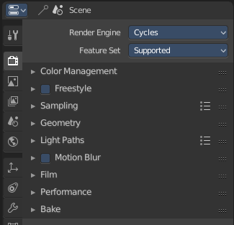
The Render tab contains the functionality and settings around the available renderers. And here you can choose the renderer with which you render your still or animation with.
There are three render engines available. OpenGL, Eevee and Cycles.
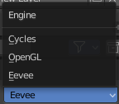

Cycles is a so called offline renderer. It is a unbiased physically correct renderer with some biased adjustments to make it useable for animations.
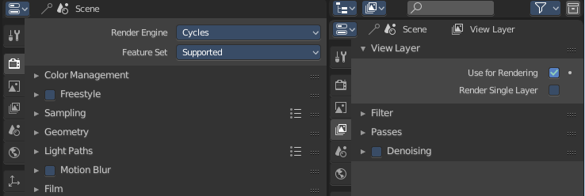
Cycles can render at the CPU or the GPU.
Eevee and OpenGL are both so called Realtime Renderers. They both render at the GPU. OpenGL relies at the OpenGL render features of the graphics card. Eevee is a full independant realtime render engine.
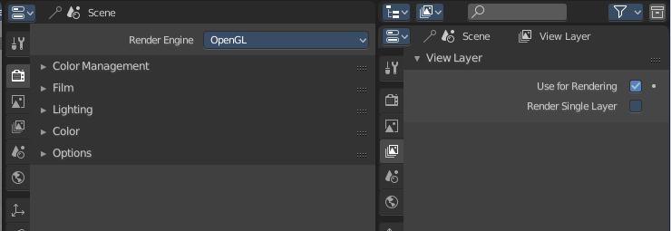
All three renderers have different settings. And the choice of the renderer influences the tab and panel content of the whole Scene section.
This content will be covererd in the chapters for the other tabs.

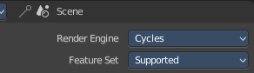
Cycles Feature Set
When you choose Cycles then you will see a new dropdown box called Feature set. Cycles has two feature set settings. Supported and Experimental.
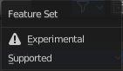
Supported means you have all common Cycles settings available.
Experimental means that you have access to some further experimental features of Cycles, which are somehow functional, but are still experimental features. Like Adaptive subdivision. Those features may or may not work proper. Use at own risk!

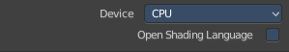
Cycles Device
When you turn on Cuda in the User Preferences then you will get a Device dropdown box where you can choose if you want to render with the CPU or the GPU.

Open Shading Language
When you render with Cycles at the CPU, then you can choose to use the Open Shading Language.

Color Management panel - All Renderers
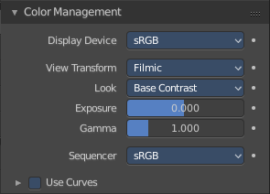
Here you will find the settings around color management. It allows an artist to make sure that an image stays the same from rendering, to saving, to post-processing. Color management also allows an artist to tweak things like exposure, gamma, or the overall color grade.
The Color Management panel is the same for all render engines.

Display Device
The device that the image is being viewed on. Your monitor.
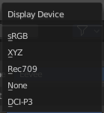
Most computer monitors are configured for the sRGB color space. Rec709 is mainly used for HDTVs. XYZ and DCI-P3 are for digital projectors.
Color management can also be disabled by setting the device to None.

View Transform
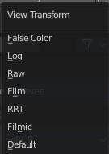
Here you can choose between different ways to view the image on the same monitor.

Default
Does no extra conversion besides the conversion for the display device.

Filmic
For more photorealistic results and better handling of high dynamic range. The contrast can be adjusted by changing the Look option for the Filmic view transform.

RRT
Uses the ACES Reference Rendering Transform, to simulate a film-like look.

Film
Uses a technique known as film emulation to give renders a look similar to what might be expected from a film-based camera. This is usually done by crushing the blacks and decreasing the contrast of the image.

Raw
Intended for inspecting the image but not for final export. Raw gives the image without any color space conversion.

Log
Intended for inspecting the image but not for final export. Log works similar to Raw but gives a more “flat” view of the image without very dark or light areas.

False Color
Shows a heat map of image intensities, to visualize the dynamic range.

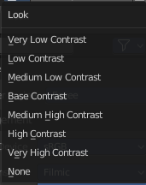
Look
Here you can adjust the contrast.

Exposure
Used to control the image brightness (in stops) applied before color space conversion. The calculation is: output_value=render_value×2(exposure)

Gamma
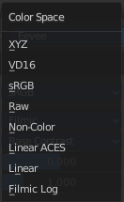
Extra gamma correction applied after color space conversion. Note that the default sRGB or Rec709 color space conversions already include a gamma correction of approximately 2.2 (except the Raw and Log views), so this would be applied in addition to that.

Sequencer Color Space
The color space that the sequencer operates in. By default, the sequencer operates in sRGB space, but it can also be set to work in Linear space like the Compositing nodes, or another color space. Different color spaces will give different results for color correction, crossfades, and other operations.

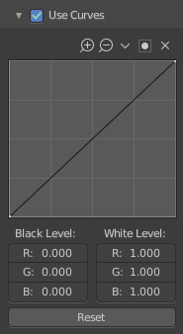
Use Curves
Here you can adjust RGB Curves to control image colors before color space conversion.

Navigation elements
The navigation elements at the top are described from left to right.

Zoom in and out
The two buttons with the magnifying glass at it zooms in and out in the curve window.

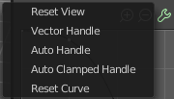
Tools
Tools is a menu where you can find some cuve related tools.

Reset View
Resets the curve windows zoom.

Vector Handle
Set handle type to Vector.

Auto Handle
Set handle type to Auto.

Auto Clamped Handle
Set handle type to Auto Clamped.

Reset Curve
Resets the curve to the initial shape.


Use Clipping
Clipping options. Here you can set up clipping for the stroke.

Delete Points
Deletes selected curve points.

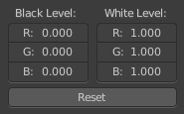
Black Level
The color that Black is mapped to.

White Level
The color that White is mapped to.

Reset
Resets the values to default values.

Cycles and Eevee - Freestyle panel

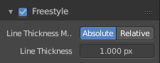
What is FreeStyle?
Freestyle is an edge- and line-based non-photorealistic (NPR) rendering engine that works on top of Cycles. It relies on mesh data and z-depth information to draw lines on selected edge types. Various line styles can be added to produce artistic or technical looks.
The two operating modes - Python Scripting and Parameter Editor - allow a diversity of line styles and results. Line styles such as Japanese big brush, cartoon, blueprint, thickness-with-depth are already pre-scripted in Python. The Parameter Editor mode allows intuitive editing of features such as dotted lines and easy setup of multiple line types and edge definitions.
There are more Freestyle settings in the View Layer tab where you can adjust and define various parameters.
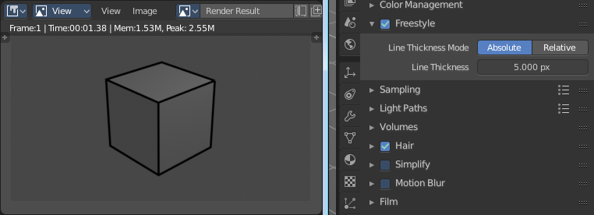
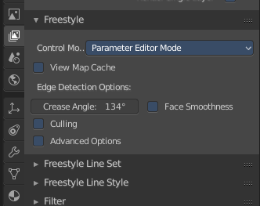

Enable
In the header is a checkbox where you can enable the Freestyle renderer.

Line Thickness Mode

Absolute
The line thickness is given by a user-specified number of pixels. The default value is 1.0.

Relative
The unit line thickness is scaled by the proportion of the present vertical image resolution to 480 pixels. For instance, the unit line thickness is 1.0 with the image height set to 480, 1.5 with 720, and 2.0 with 960.

Line Thickness
Line Thickness is only available for Absolute line thickness. The base line thickness in pixels.

Cycles - Sampling panel
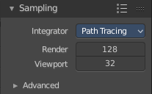
Here you can adjust the samples for Cycles.

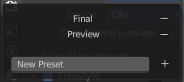
Presets
In the header you will find a Presets menu where you can choose between presets and define your own presets.

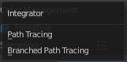
Integrator
Here you can choose between Path Tracing and Branched Path Tracing. Branched path tracing branches up on first hit. This makes each sample slower, since now there is more to calculate. But this will increase quality and reduce noise.

Render
Number of samples for the rendered image.

Viewport
Number of samples for rendering in the viewport.

Sub Samples (Branched Path Tracing)
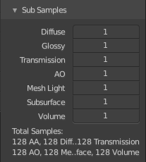
This sub panel just appears when you choose Branched Path Tracing.

Diffuse Samples
Number of diffuse bounce samples to take for each AA sample.

Glossy Samples
Number of glossy bounce samples to take for each AA sample.

Transmission Samples
Number of transmission bounce samples to take for each AA sample.

AO Samples
Number of ambient occlusion samples to take for each AA sample.

Mesh Light Samples
Number of mesh light samples to take for each AA sample.

Subsurface Samples
Number of subsurface scattering samples to take for each AA sample.

Volume Samples
Number of volume scattering samples to take for each AA sample.

Total Samples
An info string that tells you the total number of samples with the current settings.

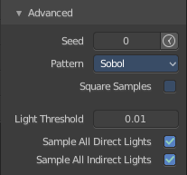
Advanced

Seed
Seed value for integrator to get different noise patterns.

Animate Seed
The clock icon besides the Seed value. Enable it to get different seed values for animation. Without animated seed you will get visible patterns in animations.

Pattern
Random sampling pattern used by the integrator.

Sobol
Uses a Sobol pattern to decide the random sapling pattern used by the integrator.

Correlated Multi-Jitter
Uses a Correlated Multi-Jitter pattern to decide the random sapling pattern used by the integrator.

Square Samples
Squares the amount samples.

Light Threshold
Terminates light samples when the light contribution is below this value. This gives more noise, but renders faster. Type in 0 to disable this feature.

Sample all direct lights (Branched Path Tracing)
Sample all direct lights rather than picking one random.

Sample all indirect lights (Branched Path Tracing)
Sample all indirect lights rather than picking one random.

Cycles - Light Paths panel
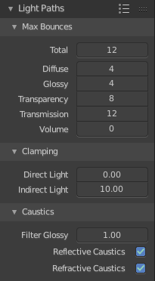
Here you will find all settings regarding light paths.

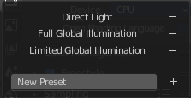
Presets
In the header you will find a Presets menu where you can choose between presets and define your own presets.

Max Bounces
A sub menu with the Maximum Bounces settings.

Total
Total maximum number of bounces.

Diffuse
Maximum number of diffuse bounces.

Glossy
Maximum number of glossy bounces.

Transparency
Maximum number of transparency bounces.

Transmission Bounces
Maximum number of transmission bounces.

Volume Bounces
Maximum number of volume scattering bounces.

Clamping
A sub menu with the Clamping settings. Clamping will reduce noise at the cost of accuracy.

Direct Light
The maxium value for a direct sample. Zero means disabled.

Indirect Light
The maximum value for a indirect sample. Zero means disabled.

Caustics
A sub menu with caustics and filter glossy settings.

Filter Glossy
When using a value higher than 0.0, this will blur glossy reflections after blurry bounces, to reduce noise at the cost of accuracy. 1.0 is a good starting value to tweak.
Some light paths have a low probability of being found while contributing much light to the pixel. As a result these light paths will be found in some pixels and not in others, causing fireflies. An example of such a difficult path might be a small light that is causing a small specular highlight on a sharp glossy material, which we are seeing through a rough glossy material. In fact in such a case we practically have a caustic.
With path tracing it is difficult to find the specular highlight, but if we increase the roughness on the material, the highlight gets bigger and softer, and so easier to find. Often this blurring will hardly be noticeable, because we are seeing it through a blurry material anyway, but there are also cases where this will lead to a loss of detail in lighting.

Reflective Caustics
Path tracing supports rendering of caustics with a sufficient number of samples. But in practice it may be inefficient to the point that there is just too much noise. Here you can disable reflective caustics.

Refractive Caustics
Path tracing supports rendering of caustics with a sufficient number of samples. But in practice it may be inefficient to the point that there is just too much noise. Here you can disable refractive caustics.

Cycles - Volumes panel

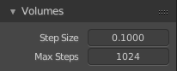
Here you can adjust the volume sampling.

Step Size
Distance between volume shader samples when rendering the volume. Lower values give more accurate and detailed results but also increased render time.

Max Steps
Maximum number of steps through the volume before giving up, to protect from extremely long render times with big objects or small step sizes.

Cycles - Subdivision panel
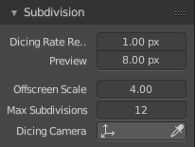
This panel is just visible when you have enabled Branched Path Tracing! Here you can control the settings for the adaptive Displacement of the experimental feature.

Dicing Rate Render
Size of micropolygons in pixels.

Preview
Size of micropolygons in pixels while preview rendering.

Offsceen Scale
Multiplier for dicing rate of geometry outside of the camera view.

Max Subdivisions
Stop subdividing when this level is reached even if the dice rate would produce finer tessellation.

Dicing Camera
Here you can choose the camera that is used as the reference point when subidviding geometry

Cycles - Hair panel
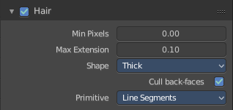
Here you can adjust the settings for Hair particles.

Min Pixels
Strands that are further away will be made wider, which is compensated with transparency to keep the look similar. This effect is only applied for camera rays. It works best with ribbon primitives.

Max Extension
Maximum extension that strand radius can be increased by

Shape
Here you can choose between the shape Thick and Ribbon

Cull Backfaces (Thick)
Cull the backface geometry. Just available for the shape Thick.

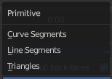
Primitive
What primitive to use for the Hair.

Triangles
Use Triangle primitives.

Resolution
The resolution of the triangle mesh.

Line Segments
Use Line Sement primitives.

Curve Segments
Use Curve primitives.

Curve Subdivision
The subdivision of the curve primitive.

Cycles - Simplify panel
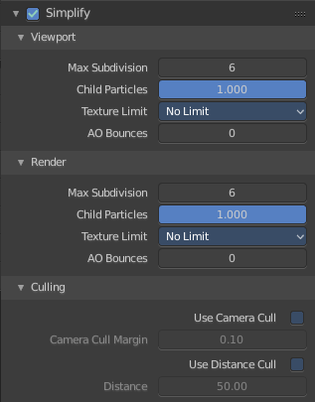

Sometimes you want to simplify the rendering without to loose the already tweaked settings and adjustments. For test renderings for example. Simplify allows you to set global limits on subdivision, shadow samples and more.

Enable
In the header is a checkbox to enable Simplify.

Viewport
This section affects the rendering with cycles in the Viewport.

Max Subdivisions
Limit the number of maximum subdivisions.

Child Particles
Limit the number of child particles.

Texture Limit
Automatically scales down textures to the chosen value.

AO Bounces
Limit the number of Ambient Occlusion Bounces.

Render
This section affects the final rendering.

Max Subdivisions
Limit the number of maximum subdivisions.

Child Particles
Limit the number of child particles

Texture Limit
Automatically scales down textures to the chosen value.

AO Bounces
Limit the number of Ambient Occlusion Bounces.

Culling
Here you can find Culling settings. Culling means that the affected geometry is excluded from calculation.

Use Camera Cull
Allow objects to be culled based on the Camera Frustum. Frustum is the region of the 3D space that gets displayed by the camera, the field of view.

Camera cull margin
The margin for the camera space culling.

Use Distance Cull
Allow objects to be culled based on the distance to the camera.

Distance
The distance after which the objects gets culled away.

Cycles - Motion Blur panel
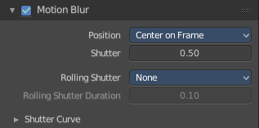
Here you can enable Motion Blur and adjust the settings.

Each object has also its own settings to control motion blur. These options can be found in the corresponding Object tab of the Properties editor.

Enable
In the header is a checkbox to enable Simplify.

Position
Controls at what point the shutter opens in relation to the frame.

Shutter
Time between frames over which motion blur is computed. Shutter time 1.0 blurs over the length of 1 frame, 2.0 over the length of two frames, from the previous to the next.

Rolling Shutter
Enable Rolling Shutter.

Rolling Sutter Duration
Controls balance between pure rolling shutter effect and pure motion blur effect. With zero being no rolling shutter and one being all rolling shutter.

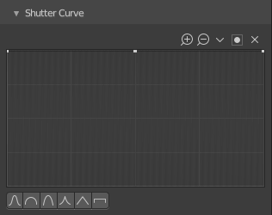
Shutter Curve
Sutter curve is a sub menu where you can adjust a curve for the shutter effect.

Navigation elements
The navigation elements at the top are described from left to right.

Zoom in and out
The two buttons with the magnifying glass at it zooms in and out in the curve window.

Tools
Tools is a menu where you can find some cuve related tools.

Reset View
Resets the curve windows zoom.

Vector Handle
Set handle type to Vector.

Auto Handle
Set handle type to Auto.

Auto Clamped Handle
Set handle type to Auto Clamped.

Reset Curve
Resets the curve to the initial shape.

Use Clipping
Clipping options. Here you can set up clipping for the stroke.

Delete Points
Deletes selected curve points.

Black Level
The color that Black is mapped to.

White Level
The color that White is mapped to.

Reset
Resets the values to default values.

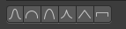
Presets
At the bottom you can find some curve presets.

Cycles - Film panel
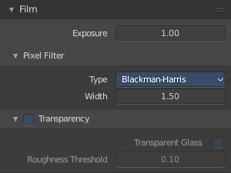

Exposure
Exposure can be used to change the brightness of an image. Different then the Exposure option found in the Color management panel this exposure option works is on the data while the Color management exposure is on the view.

Pixel Filter
The Pixel Filter randomly changes the coordinates of every sample with the given distribution. For example: When the Sobol Sampling Pattern samples near the edge of the pixel, the neighbouring pixel might be lit instead with a rather high probability. Pixel filter is used to get rid of aliasing on the sharp edge of very bright objects, like mesh lights.

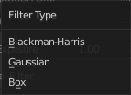
Type
Here you can choose the pixel filter type.

Width
Here you can adjust the pixel filter width.

Transparent
Adds an alpha channel to the rendering, and enables to have transparent areas.

Transparent Glass
Renders transmissive surfaces as transparent areas.

Roughness Threshold
Keep transparent glass with a roughness above the threshold opaque.

Cycles - Performance panel

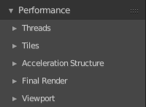
Here you can find settings to influence the render performance.

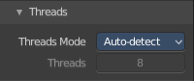
Threads

Mode

Auto-detect
Automatically chooses the amount threads to match the number of logical processors on your computer.

Fixed
Here you can manually choose the amount threads to use for rendering.

Threads
Just active when you choose Fixed. Number of threads that you want to use.

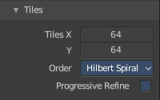
Tiles

Tile size X/Y
The size of the tiles for rendering.
Depending on what device you are using for rendering, different tile sizes can give faster renders. For CPU rendering smaller tiles sizes (like 32 x 32) tend to be faster, while for GPU rendering larger tile sizes give better performance (like 256 x 256).

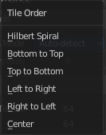
Order
Order of rendering tiles. This does not significantly affect performance.

Progressive Refine
Instead of rendering each tile until it has finished every sample, refine the whole image progressively. Note that progressive rendering is slightly slower than tiled rendering, but time can be saved by manually stopping the render when the noise level is low enough.
For rendering animations it is best to disable this feature, as stopping a frame early is not possible.

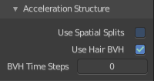
Acceleration Structure

Use Spatial Splits
Spatial splits improve rendering performance in scenes with a mix of large and small polygons. The downsides are longer BVH build times and slightly increased memory usage.

Use Hair BVH
Use a special type of BVH for rendering hair. The bounding boxes are not axis aligned allowing a spatially closer fit to the hair geometry. Disabling this option will reduce memory, at the cost of increasing hair render time.

BVH Time Steps
Is active when Spatial Splits is off. Split BVH Primitives by this number of time steps. This speeds up rendering, but requires more memory.

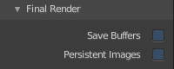
Final Render

Save Buffers
Saves all render layers and passes to the temp directory on a drive, and read them back after rendering has finished. This saves memory usage during rendering, particularly when using many render layers and passes.

Persistent Images
Keep image data in memory after rendering, for faster re-renders at the cost of extra memory usage when performing other tasks in Blender.

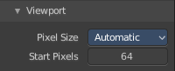
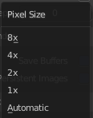
Viewport
This settings is for rendering in the Viewport.

Pixel Size
Pixel Size for Viewport Rendering.

Start Pixels
The resolution to start rendering at. And then progressively increase it to the full viewport rendering.

Cycles - Bake panel

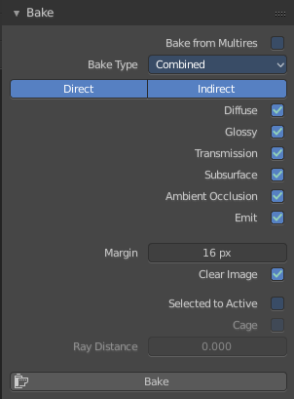
Texture baking is the process to bake specific informations from one object into the texture or the vertex colors of another object. Ambient Occlusion. Or a Normal Map for example.

NOTE
Baking into textures requires to have a working UV mapping and a texture at the target object!

How to use: Select the source object where you want to bake from, hold down Shift, select the target object where you want to bake to, so that both objects are selected. Adjust the settings to your needs. Then hit the Bake button.

NOTE
The Bake panel is visible in all Modes. But you have to bake in Object Mode.

Settings for all Texture types
Most settings in the Bake panel are available for all texture types.

Bake Type
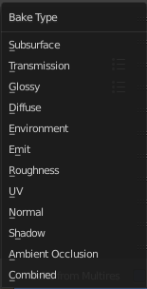
Bake Mode is a drop-down box where you can choose what type of information you want to bake from the source object into the texture or the vertex colors of the target object.
You can bake Subsurface, Transmission, Glossy, Diffuse, Environment, Emit, UV, Normal, Shadow, Ambient Occlusion and Combined.

Subsurface
Bakes the Subsurface Passes of a material into the texture of the target object.

Transmission
Bakes the transmission Passes of a material into the texture of the target object.

Glossy
Bakes the Glossy Passes of a material into the texture of the target object.

Environment
Bakes the Environment texture into the texture of the target object. As seen from the center of the object.

Emit
Bakes the Emission or the glow color of a material into the texture of the target object.

Roughness
Bakes the Roughness of a material into the texture of the target object.

UV
Bakes colors of materials and textures only, without shading.

Normals
Creates a Normal map by using the normals of the source object, and baking them as colors into the texture of the target object.

Shadow
Bakes the Shadow into the texture of the target object.

Ambient Occlusion
Bakes ambient occlusion as specified in the World panels. Ignores all lights in the scene.

Combined
Bakes the full rendering, means materials, textures, lightning, into the texture of the target object. Except Specularity.


Margin
Adjust the margin width.

Clear Image
Clear clears the target image before baking.

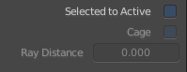
Selected to Active
The usual way to bake is first select the Source Object, where you want to bake from, hold down Shift, select the target object where you want to bake to, so that both objects are selected. Then hit the Bake button. That's Selected to Active.

Cage
This setting is hidden as long as Selected to active is not ticked.
Cast Rays to active object from a cage.

Ray Distance
Distance to use for the inward ray cast when using Selected to Active.

Bake
The Bake Button will start the baking process.

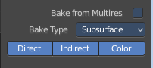
Settings for specific Texture types

Subsurface, Transmission, Glossy, Diffuse

Direct
Add direct Light.

Indirect
Add indirect Light.

Color
Add Color.

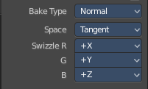
Normal

Space
A drop-down box where you can chooses the Normal Space to use.

Swizzle
Axis to bake in red, green and blue channels.

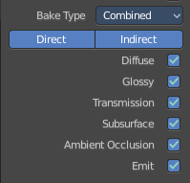
Combined

Direct
Bake directly from Multires mesh.

Indirect
Normalizes without using material settings.

Diffuse
Bake with Diffuse.

Glossy
Bake with Glossy.

Transmission
Bake with Transmission.

Subsurface
Bake with Subsurface.

AO
Bake with Ambient Occlusion.

Emit
Bake with Emit.

OpenGL - Lighting panel
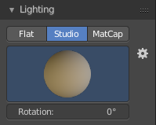
OpenGL rendering is not influenced by the lights that you place in the workspace. But by a special OpenGL light setup. It can be tweaked in the Lighting panel and the User Preferences.

Flat
Use a flat lighting.

Studio
Use a Studio light setup.

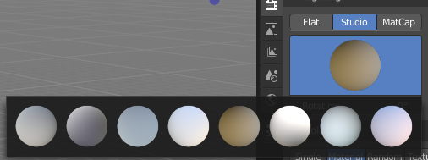
Light library browser
Here you can choose a predefined studio light setup.

Rotation
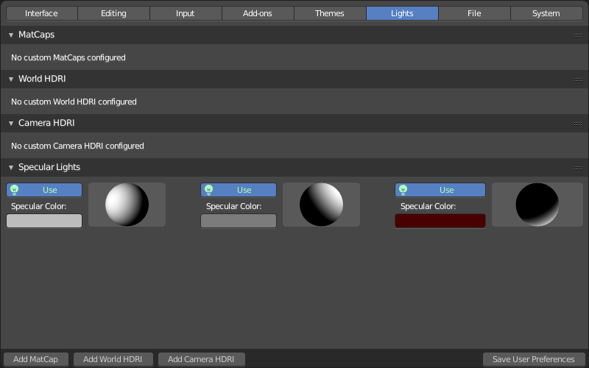
Rotate the studio light setup.

User Preferences
A click at this button opens up the user preferences where you can add and manage the OpenGL Lights.

Matcap
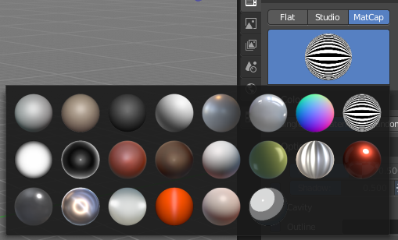
Use Matcaps to render the scene.

User Preferences
A click at this button opens up the user preferences where you can add and manage theMatcaps.

Flip Matcap
Flips the matcap.

OpenGL - Color panel

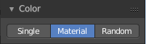
Here you can define the color of the surface of the object. This settings are dependant of the chosen lighting.

Single
Uses a single color for the mesh.

Material
Uses the material including textures for the mesh.

Random
Uses a random color for the mesh.

Texture
Renders the texture, and ignores the material settings.

OpenGL - Options panel
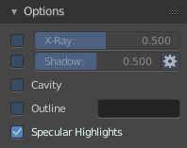

X Ray
Render the faces transparent

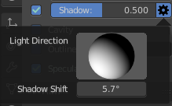
Shadow
Render Shadow

Shadow Shift
Here you can adjust a shadow shift relative to the light source.

Cavity
Show Cavity

Outline
Render a outline. The outline size is defined with one pixel.

Specular Highlights
Render specular highlights.

OpenGL - Film panel

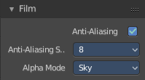
Here you can find film settings.

Anti Aliasing
Use Antialias.

Anti Aliasing Sample
Here you can adjust the Anti Aliasing Sample rate.

Alpha Mode
Here you can define the alpha mode.

Sky
Transparent pixels are filled with Sky color

Transparent
World Background is transparent. Transparency is premultiplied Alpha.

OpenGL - Simplify panel

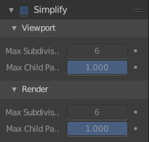
Sometimes you want to simplify the rendering without to loose the already tweaked settings and adjustments. For test renderings for example. Simplify allows you to simplify the rendering.

Enable
In the header is a checkbox to enable Simplify.

Viewport
This section affects the rendering with OpenGL in the Viewport.

Max Subdivisions
Limit the number of maximum subdivisions.

Child Particles
Limit the number of child particles.

Render
This section affects the rendering with OpenGL to file.

Max Subdivisions
Limit the number of maximum subdivisions.

Child Particles
Limit the number of child particles.

Eevee - Sampling panel
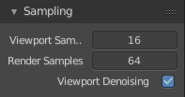

Viewport Samples
The number of samples when rendering in the viewport.

Render Samples
The number of samples when rendering to file.

Viewport Denoising

Denoise Image. The temporal reprojection can cause some ghosting.

Eevee - Ambient Occlusion panel
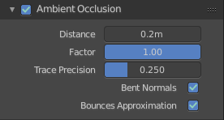
Ambient occlusion is a self shadowing effect.

Enable
In the header you will find a checkbox to enable the Ambient Occlusion.

Distance
The distance of the object to contribute to the ambient occlusion.

Factor
The blend factor

Trace Precision
Precision of the horizon search

Bent Normals
Compute the main non occluded direction to sample the environment

Bounces Approximation
An approximation to simulate light bounces gives less occlusion on brighter objects.

Eevee - Bloom panel

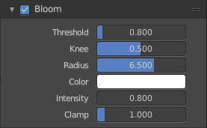
Enable
In the header you will find a checkbox to enable the Bloom.

Threshold
Filters out pixel that are below this level of brightness.

Knee
Makes transition between under / over threshold gradual.

Radius
Bloom spread distance.

Color
The color of the bloom effect.

Intensity
Blend Factor.

Clamp
Maximum intensity a bloom pixel can have.

Eevee - Depth of Field panel

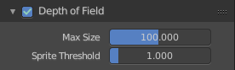
Enable
In the header you will find a checkbox to enable the Depth of Field.

Max Size
The maximum size of the bokeh shape for Depth of Field. Lower is faster.

Sprite Threshold
Brightness threshold for using sprite base Depth of Field.

Eevee - Subsurface Scattering panel

Subsurface scattering is a mechanism of light transport through the object. It penetrates the surface of a translucent object, is scattered by interacting with the material, and exits the surface at a different point.

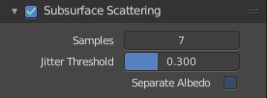
Enable
In the header you will find a checkbox to enable the Subsurface Scattering.

Samples
Number of samples to compute the scattering effect.

Jitter Threshold
Rotate samples that are below this value.

Separate Albedo
Avoid albedo being blurred by the subsurface scattering. This feature uses more memory.

Eevee - Screen Space reflections panel

Here you can find settings around the Sceen Space reflections.

Screen Space Reflections is a common technique in games. It reuses the information that is already on screen for reflections. It doesn't reflect geometry outside of the camera though.

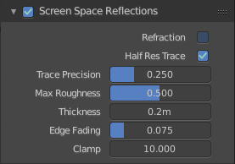
Enable
In the header you will find a checkbox to enable the Subsurface Scattering.

Refraction
Enable Screen Space refraction.

Half Res Trace
Raytrace at a lower resolution.

Trace Precision
The precision of the screen space raytracing.

Max Roughness
Do not raytrace reflections that are above this value.

Thickness
Pixel thickness used to detect intersections.

Edge Fading
Screen percentage used to fade the Screen Space Reflection.

Clamp
Clamp Pixel intensity to remove noise.

Eevee - Motion Blur panel

Here you can find settings for motion blur.

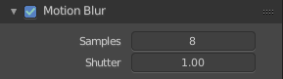
Enable
In the header you will find a checkbox to enable the Subsurface Scattering.

Samples
Nunber of samples for motion blur.

Shutter
Time taken in frames between shutter open and close.

Eevee - Volumetric panel

Here you can find volumetrics settings.

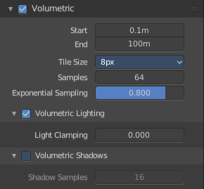
Enable
In the header you will find a checkbox to enable Volumetric.

Start
The start distance for volumetrics.

End
The end distance for volumetrics.

Tile Size
The quality of the volumetrics effect. The lower the size the higher the quality and ram useage.

Samples
Number of samples to compote for the volumetrics effect.

Exponential sampling
Distribute more samples closer to the camera.

Volumetric Lighting

Enable
In the header you will find a checkbox to enable Volumetric Lighting.

Light Clamping
The maximum light contribution.

Volumetric Shadows

Enable
In the header you will find a checkbox to enable Volumetric Shadows.

Shadow samples
Number of samples to compute volumetric shadowing.

Eevee - Hair panel

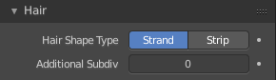
Hair Shape Type
Choose if the hair is displayed as strand or as strip.

Animate Property
This property can be animated. Activating this button sets a keyframe.

Additional Subdiv
Additional subdivision along the hair.

Animate Propterty
This property can be animated. Activating this button sets a keyframe.

Eevee - Shadows panel
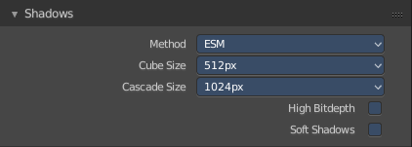
Here you can find settings regarding shadows.

Method
Here you can choose between ESM and VSM method for the shadow. ESM stands for exponential shadow mapping. VSM stands for Variance shadow mapping.

Cube Size
The cube shadows resolution.

Cascade Size
Directional shadows resolution.

High Bitdepth
Use 32 bit shadows. Low bitdepth uses 8 bit.

Soft Shadows
Create soft shadows.

Eevee - Indirect Lighting panel
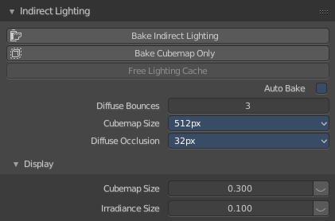
Indirect lighting can be baked to speed up the rendering process.

Eevee uses irradiance probes to calculate indirect lighting.

Bake Indirect Lighting
Bake both, the irradiance grids and reflection cubemaps.

Bake Cubemap Only
Bakes only the reflection cubemaps.

Free Lighting Cache
Delete baked informations from cache.

Auto Bake
Auto bake indirect lighting when editing probes.

Diffuse Bounces
Number of times the light is reinjected inside light grids. 0 will disable indirect diffuse light.

Cubemap Size
The size of the cubemaps.

Diffuse Occlusion
The size of the shadow map applied to each irradiance sample.

Display

Cubemap Size
Size of cubemap spheres to debug captured light.

Irradiance Size
Size of the irradiance sample spheres to debug captured light.

Eevee - Film panel
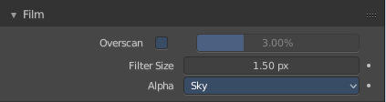

Overscan
Internally render past the image borders to avoid screen space effects disappearing.

Overscan Size
How much bigger the image should be internally rendered.

Filter Size
The width over which the reconstruction filter combines samples.

Animate Propterty
This property can be animated. Activating this button sets a keyframe.

Alpha Mode
Here you can define the alpha mode.

Sky
Transparent pixels are filled with Sky color

Transparent
World Background is transparent. Transparency is premultiplied Alpha.

Animate Propterty
This property can be animated. Activating this button sets a keyframe.

Eevee - Simplify panel
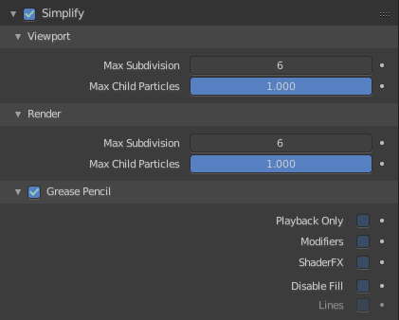
Sometimes you want to simplify the rendering without to loose the already tweaked settings and adjustments. For test renderings for example. Simplify allows you to simplify the rendering

.

Enable
In the header is a checkbox to enable Simplify.

Viewport
This section affects the rendering with Eevee in the Viewport.

Max Subdivisions
Limit the number of maximum subdivisions.

Child Particles
Limit the number of child particles.

Animate Propterty
This properties can be animated. Activating this button sets a keyframe.

Render
This section affects the rendering with Eevee to file.

Max Subdivisions
Limit the number of maximum subdivisions.

Child Particles
Limit the number of child particles.

Animate Propterty
This properties can be animated. Activating this button sets a keyframe.

Grease Pencil
This section affects Grease Pencil drawings.

Playback Only
Simplify Grease Pencil only during animation playback.

Modifiers
Do not apply modifiers in the viewport

Shader FX
Do not apply shader FX.

Disable Fill
Disable fill strokes in the viewport.

Lines
Disable external lines of fill strokes. This feature is just active when Disable Fill is checked.

Animate Propterty
This properties can be animated. Activating this button sets a keyframe.

